Local development environment

OS: Windows 7

Operational Toolkits: PuTTY WinSCP

Development Toolkits: Eclipse kepler (JAVA), JDK 1.7.0.45, CouchDB 1.5.1

Tweets Harvesting Application

Install packages

1. Curl

sudo apt-get install curl

1. Oracle Java JDK7

http://www.webupd8.org/2012/01/install-oracle-java-jdk-7-in-ubuntu-via.html

sudo add-apt-repository ppa:webupd8team/java

sudo apt-get update

sudo apt-get install oracle-java7-installer

java -version

sudo apt-get install oracle-java7-set-default

1. CouchDB

https://wiki.apache.org/couchdb/Installing_on_Ubuntu

sudo apt-get install couchdb -y

curl http://127.0.0.1:5984/

binding to all interfaces

/etc/couchdb/default.ini

/etc/couchdb/local.ini

bind_address = 0.0.0.0

sudo service couchdb restart

sudo /etc/init.d/couchdb restart doesn't work

(looks old version cannot stop couchdb unitl kill erlang process)

/var/lib/couchdb database default directory

1. Tomcat

https://help.ubuntu.com/13.10/serverguide/tomcat.html

sudo apt-get purge tomcat6 && sudo apt-get autoremove (uninstall tomcat6)

(installment of tomcat6 would cause unexpected result, tomcat 7 is right)

sudo apt-get install tomcat7

if you are using extracted tomcat then, startup.sh and shutdown.sh are two script located in TOMCAT/bin/ to start and shutdown tomcat, You could use that

if tomcat is installed then

/etc/init.d/tomcat7 start

/etc/init.d/tomcat7 stop

/etc/init.d/tomcat7 restart

/etc/tomcat7/server.xml

/etc/tomcat7/tomcat-user.xml

/var/lib/tomcat7/webapps/ROOT/

Deployment

* + 1. copy the .war file in the webapps folder
    2. upload the file using the manager application - http://host:port/manager. You will have to setup some users beforehand.
    3. (not recommended, but working) - manually extract the .war file as a .zip archive and place the extracted files in webapps/webappname

Sometimes administrators configure tomcat so that war files are deployed outside the tomcat folder. Even in that case:

After you have it deployed (check the /logs dir for any problems), it should be accessible via: http://host:port/path/.

Volume binding

1. sudo fdisk -l

2. sudo mkfs.ext4 /dev/vdc

3. sudo mkdir /mnt/data

sudo mount /dev/vdc /mnt/data

sudo chown -R ubuntu /mnt/data

4. sudo ls /var/lib/couchdb

5. sudo cp -R -p /var/lib/couchdb /mnt/data/

sudo ls /mnt/data/couchdb

6. sudo vi /etc/couchdb/local.ini

[couchdb]

database_dir = /mnt/data/couchdb

7. sudo vi /etc/apparmor.d/tunables/alias

alias /var/lib/couchdb/ -> /mnt/data/couchdb/,

sudo /etc/init.d/apparmor restart

8. sudo service couchdb restart

Executing Jar

cd Team6

sudo nohup java jar tweet.jar &

ps -ef|grep tweet

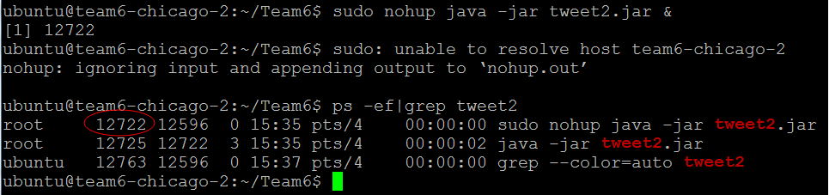

sudo kill -9 12722

sudo tail -f nohup.out